12.25: The escape speed, from the results of Example 12.5, is 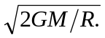

a)

b)

c) Both the kinetic energy and the gravitational potential energy are proportional to the mass.

